Insert your name, centre number and candidate number into the header above.
Save this evidence document as evidence_ followed by your centre number_ candidate number. For example: evidence_ zz999_9999
Screenshots or program listings must be copied into appropriate cells in the following tables.
Examiners must be able to read the contents including any screenshots without the use of a magnifying glass. Answers that are not readable or missing will not be awarded any marks.
Save this evidence document at regular intervals, for example, every 10 minutes.
Question 1
Part 1(a)
class node:
def __init__(self, data, nextNode):
self.data = data
self.nextNode = nextNode

Part 1(b)
def main():
linkedList = [None] * 10
startPointer = 0
emptyList = 5
linkedList[0] = node(1, 1)
linkedList[1] = node(5, 4)
linkedList[2] = node(6, 7)
linkedList[3] = node(7, -1)
linkedList[4] = node(2, 2)
linkedList[5] = node(0, 6)
linkedList[6] = node(0, 8)
linkedList[7] = node(56, 3)
linkedList[8] = node(0, 9)
linkedList[9] = node(0, -1)
if __name__ == "__main__":
main()

Part 1(c)(i)
def outputNodes(startPointer, linkedList):
idx = startPointer
while idx != -1:
print(linkedList[idx].data)
idx = linkedList[idx].nextNode

Part 1(c)(ii)
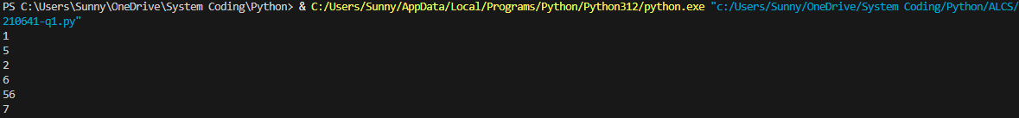

Part 1(d)(i)
def addNode(linkedList, startPointer, emptyList):
if emptyList < 0 or emptyList > 9:
return False
else:
linkedList[emptyList] = node(int(input("Enter number to be added: ")), -1)
idx = startPointer
while True:
if linkedList[idx].nextNode == -1:
break
idx = linkedList[idx].nextNode
linkedList[idx].nextNode = emptyList
emptyList = linkedList[emptyList].nextNode
return True

Part 1(d)(ii)
def main():
linkedList = [None] * 10
startPointer = 0
emptyList = 5
linkedList[0] = node(1, 1)
linkedList[1] = node(5, 4)
linkedList[2] = node(6, 7)
linkedList[3] = node(7, -1)
linkedList[4] = node(2, 2)
linkedList[5] = node(0, 6)
linkedList[6] = node(0, 8)
linkedList[7] = node(56, 3)
linkedList[8] = node(0, 9)
linkedList[9] = node(0, -1)
outputNodes(startPointer, linkedList)
if addNode(linkedList, startPointer, emptyList):
print("Sucessfully added")
else:
print("Failed to add.")
outputNodes(startPointer, linkedList)

if __name__ == "__main__":
main()

Part 1(d)(iii)
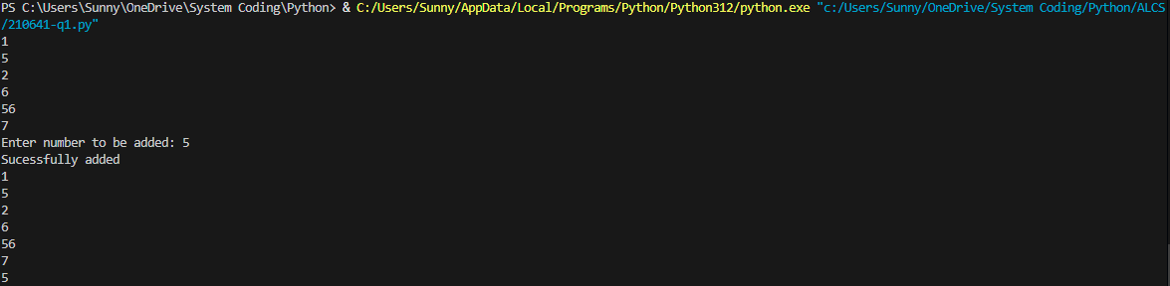

Question 2
Part 2(a)
global arrayData
arrayData = [10, 5, 6, 7, 1, 12, 13, 15, 21, 8]

Part 2(b)(i)
def linearSearch(x):
for i in range(len(arrayData)):
if arrayData[i] == x:
return True
return False

Part 2(b)(ii)
def main():
if (linearSearch(int(input("Enter an integer: ")))):
print("Integer found!")
else:
print("Intger not found.")

if __name__ == "__main__":
main()

Part 2(b)(iii)

Part 2(c)
def bubbleSort():
for x in range(len(arrayData)):
for y in range(len(arrayData) - 1):
if arrayData[y] < arrayData[y + 1]:
arrayData[y], arrayData[y + 1] = arrayData[y + 1], arrayData[y]

Question 3
Part 3(a)
class TreasureChest:
def __init__(self, question, answer, points):
self.__question = question #string
self.__answer = answer #string
self.__points = points #integer

Part 3(b)
arrayTreasure = [None]
def readData():
global arrayTreasure
try:
with open("TreasureChestData.txt", encoding='utf-8') as f:
for i in range(5):
arrayTreasure.append(TreasureChest(f.readline().strip(), f.readline().strip(), int(f.readline().strip())))
except FileNotFoundError:
print("File not found.")

Part 3(c)(i)
def getQuestion(self):
return self.__question

Part 3(c)(ii)
def checkAnswer(self, ans):
return ans == self.__answer

Part 3(c)(iii)
def getPoints(self, n):
if n == 1:
return self.__points
elif n == 2:
return self.__points // 2
elif n == 3 or n == 4:
return self.__points // 4
else:
return 0

Part 3(c)(iv)
def main():
readData()
num = int(input("Enter a question number between 1~5: "))
print(arrayTreasure[num].getQuestion())
cnt = 0
while True:
cnt += 1
if arrayTreasure[num].checkAnswer(input()):
break
else: print("Try again:", end="")
print("You earned " + str(arrayTreasure[num].getPoints(cnt)) + " points!")

if __name__ == "__main__":
main()

Part 3(c)(v)
